**OpenPCBLGR**

An open-source loop-gap resonator (LGR)

for x-band EPR spectroscopy

Technical Description and Assembly Manual

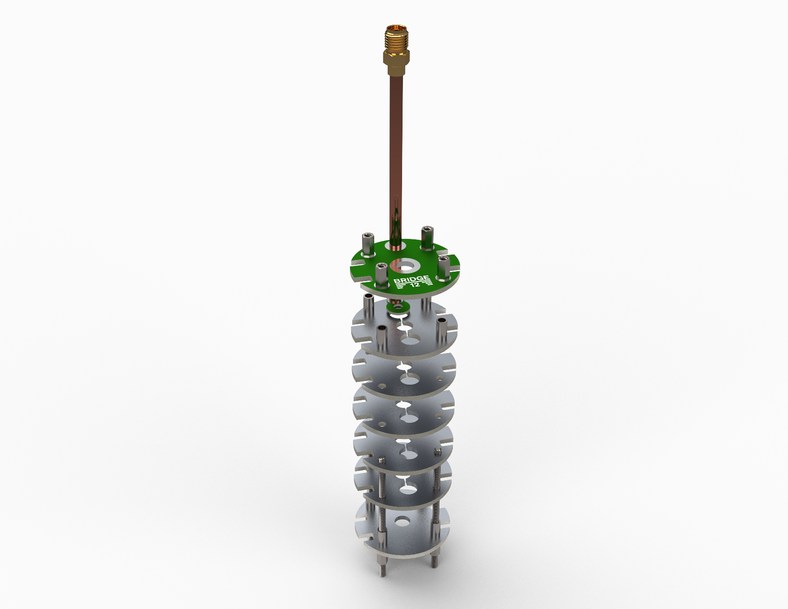 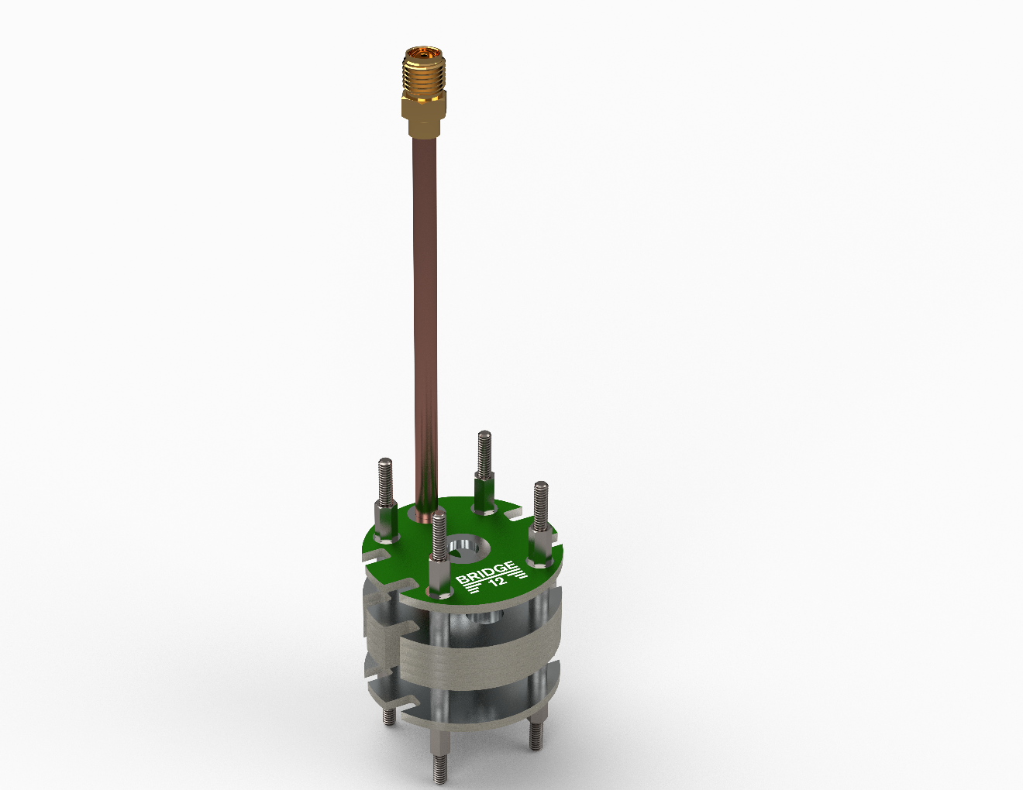

# Description

# Assembly Instructions

## Assembling SMA Coupling Loop

The first step is assembling the SMA coupling loop.

1. Cut semi-rigid coax to length with a tube cutter. Cut the outer shield on both sides and leave ~0.15 in of inner conductor exposed.

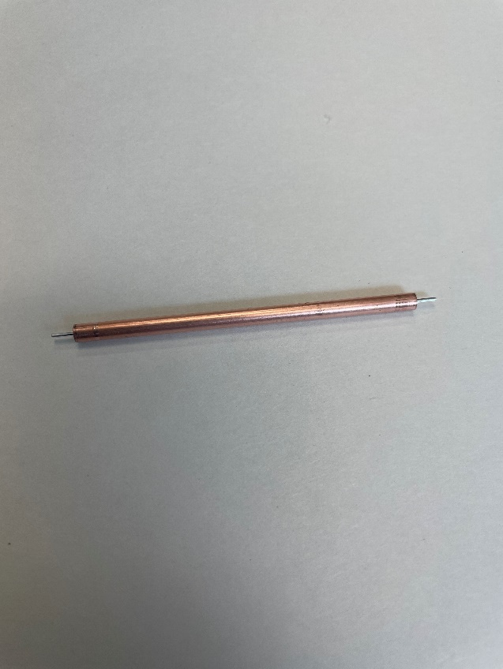

1. Solder PCB coupling loop to semi-rigid coax cable. Clip any excess inner conductor length with a side cutter. If any additional stub remains, the stub can be removed with sandpaper or a file.

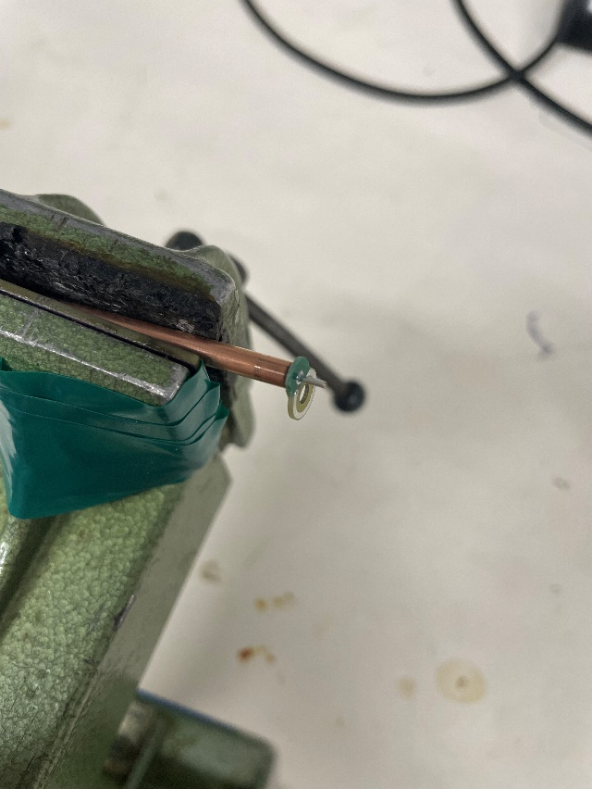

Add the PCB LGR “top” to the semi-rigid coax. This step must be performed before the SMA connector is soldered to the semi-rigid coax cable.  
Solder the SMA connector to the semi-rigid coax cable following the assembly 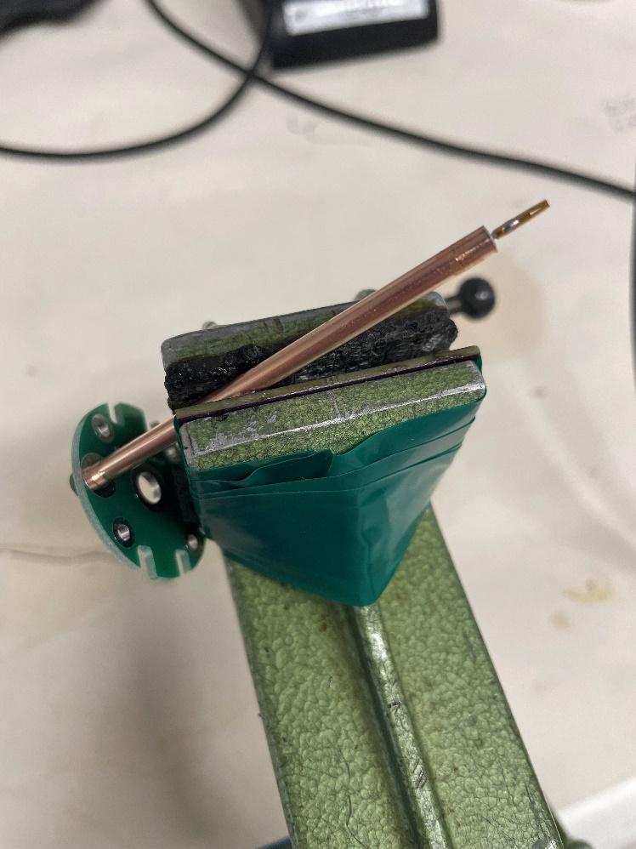instructions for the SMA connector

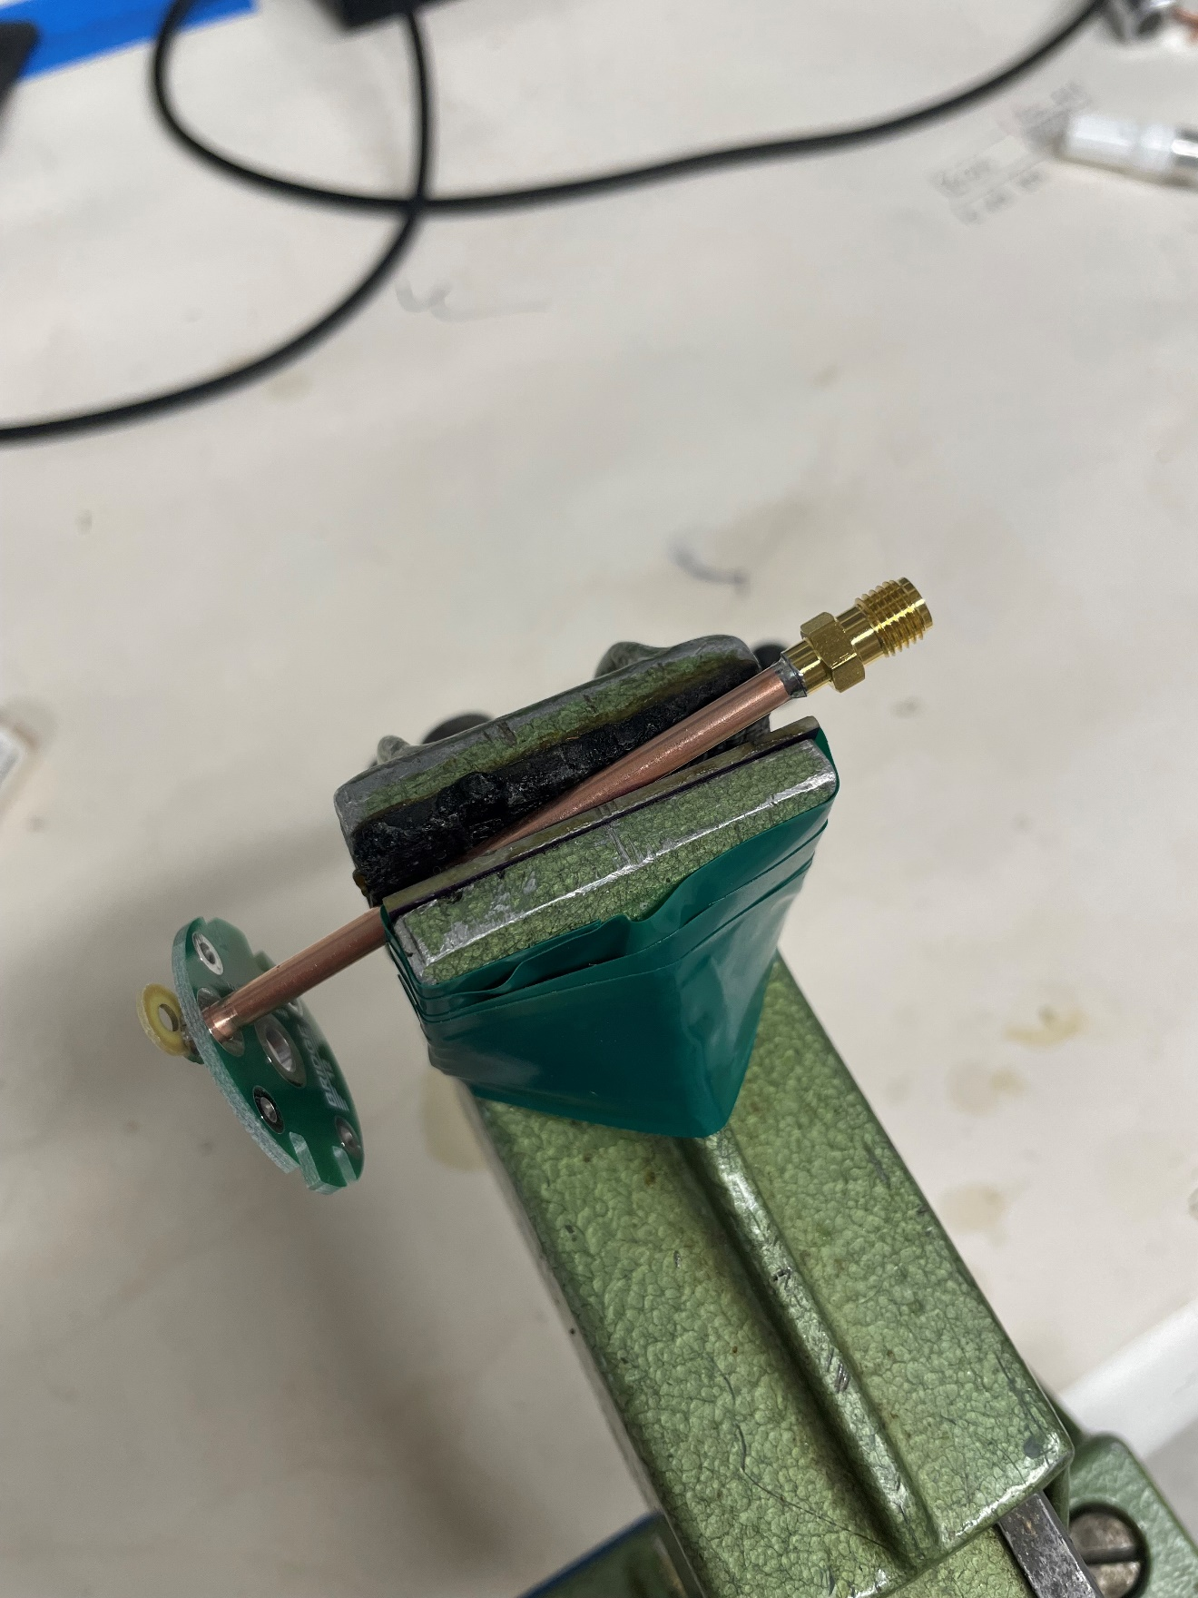

1. Mark the orientation of the coupling loop with a permanent marker (see red mark in picture). This will make identifying the orientation of the coupling loop easier later.

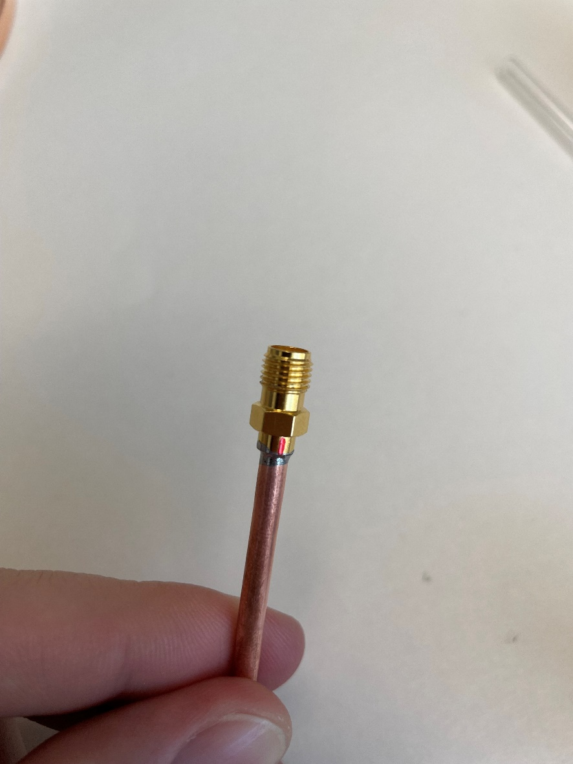

## Assembling the Resonator

1. Screw standoff onto 2-56 threaded rod. Leave 0.250 in. of thread on the rod. Repeat for all 4 threaded rods.

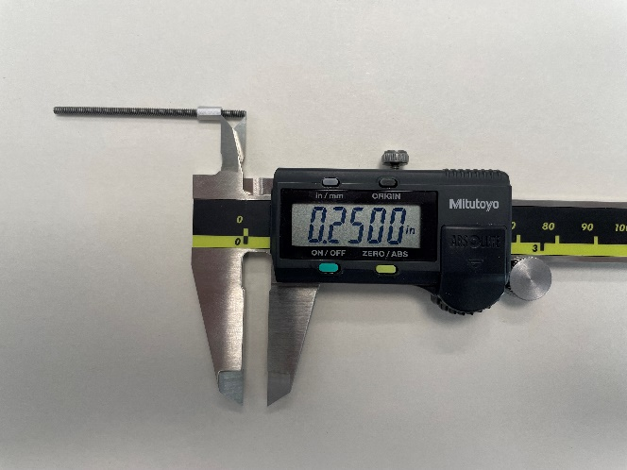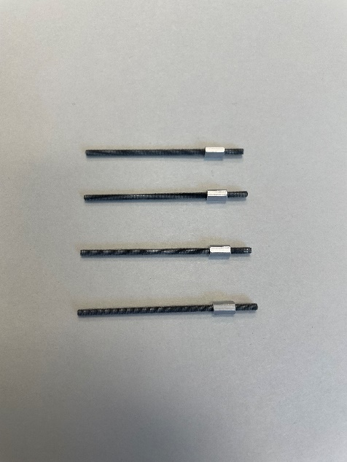

1. Slide PCB LGR bottom onto the 2-56 threaded rods onto PCB LGR bottom.

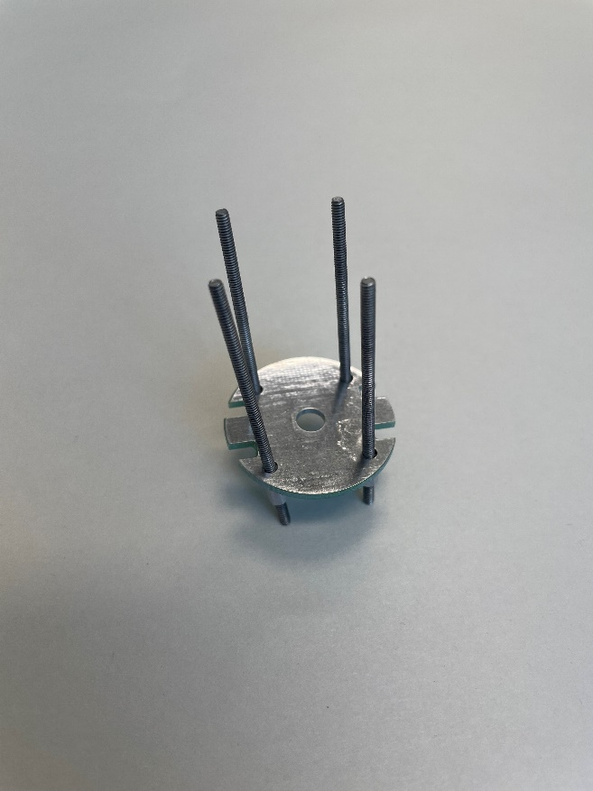

1. Add 0.250 in spacers to each threaded rod

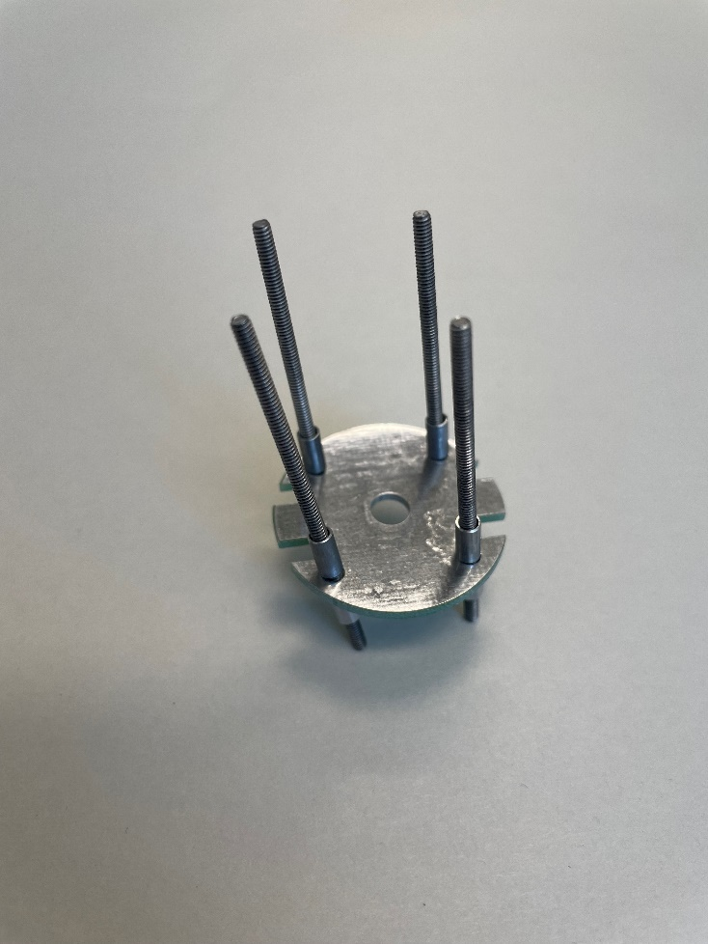

1. Add PCB LGR sections (quantity of 5 is recommended)

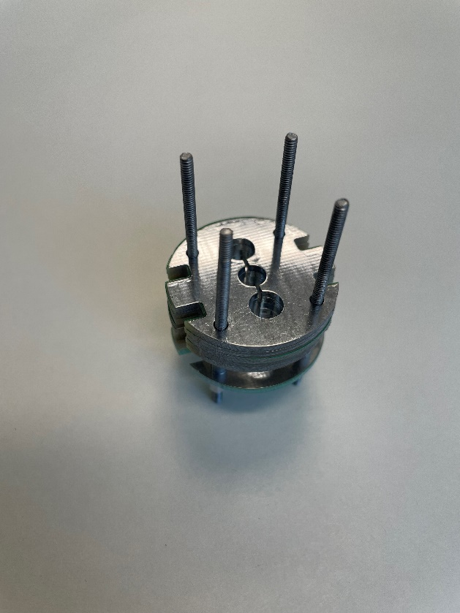

1. Add 0.250 in spacers to each threaded rod.
2. Add PCB LGR top with coupling loop assembled as shown.

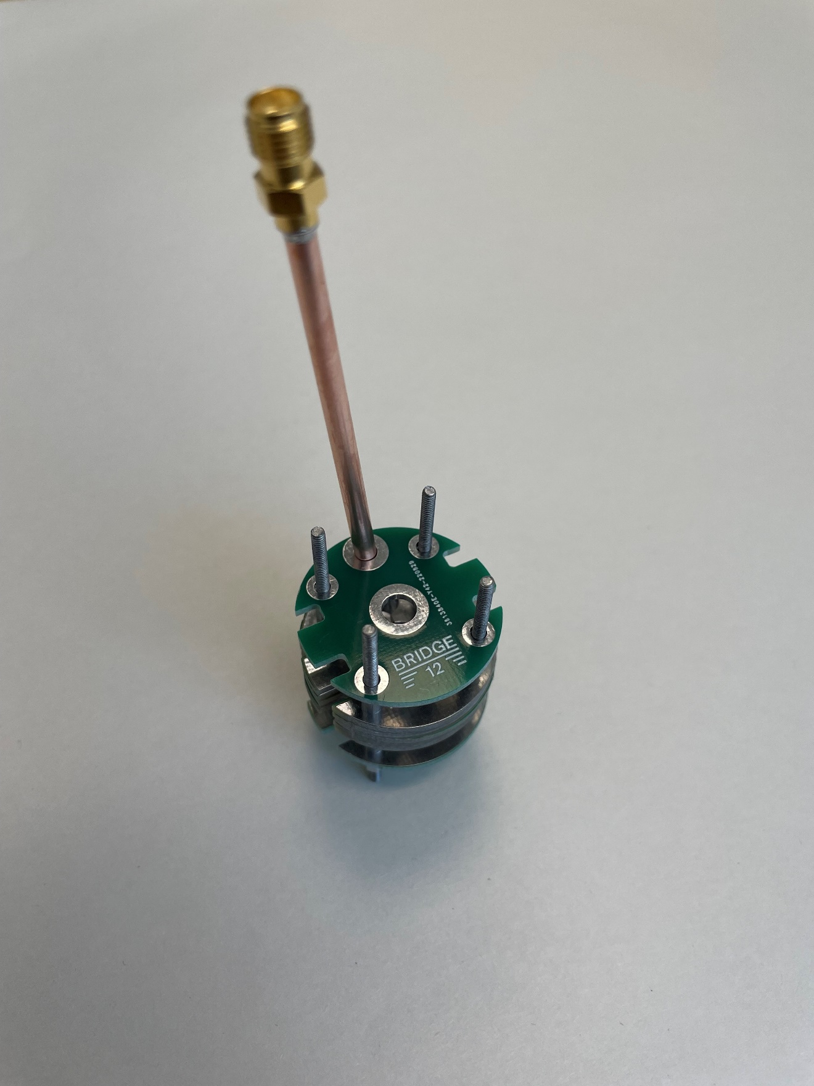

1. Screw on 0.250 in standoffs to 2-56 threaded rod. Leave slightly loose for positioning.

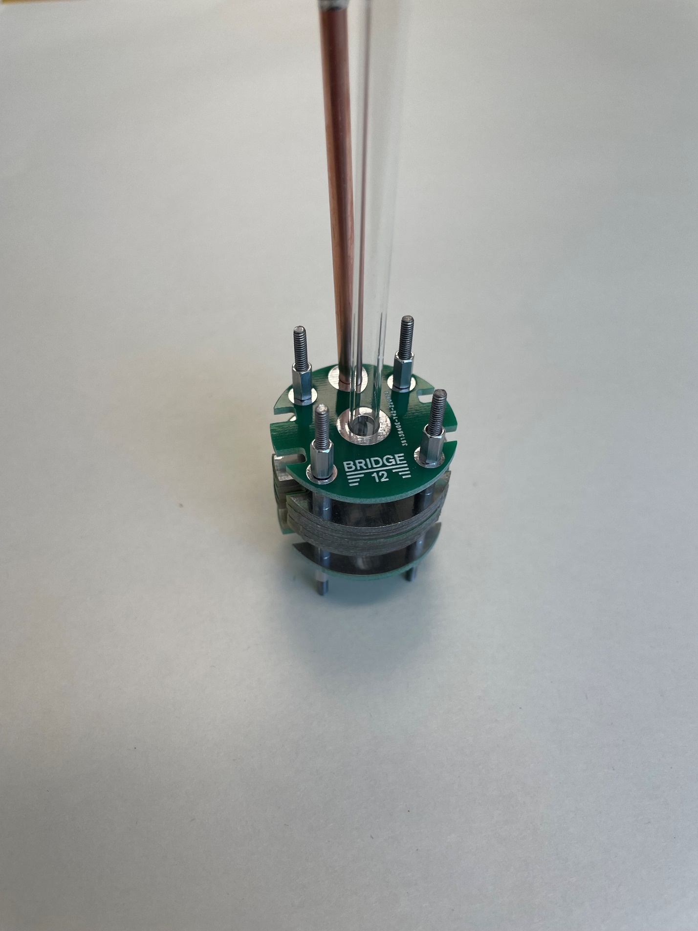

1. Align all PCBs. If available, a 5mm capillary can be used to help align all the PCBs.
2. Tighten the standoffs to secure the assembly. The bottom should have 0.250 in of thread exposed.
3. The final assembled LGR should appear as shown:

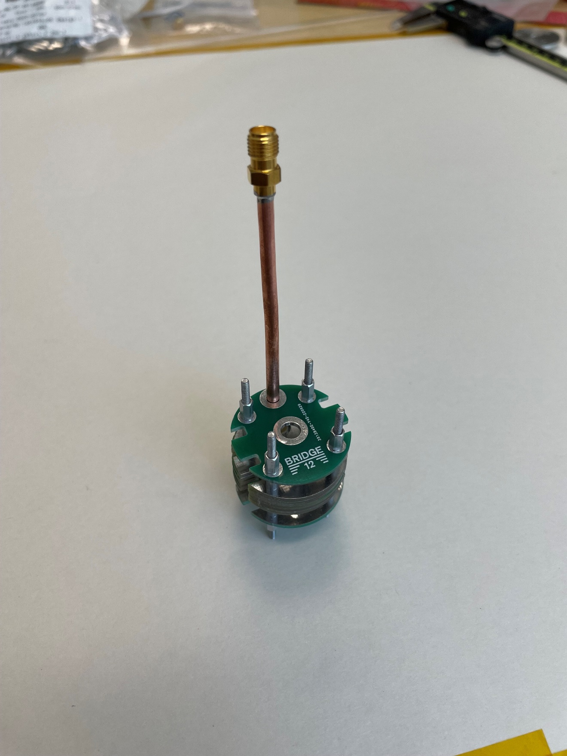

## Applying Copper Tape to PCB LGR

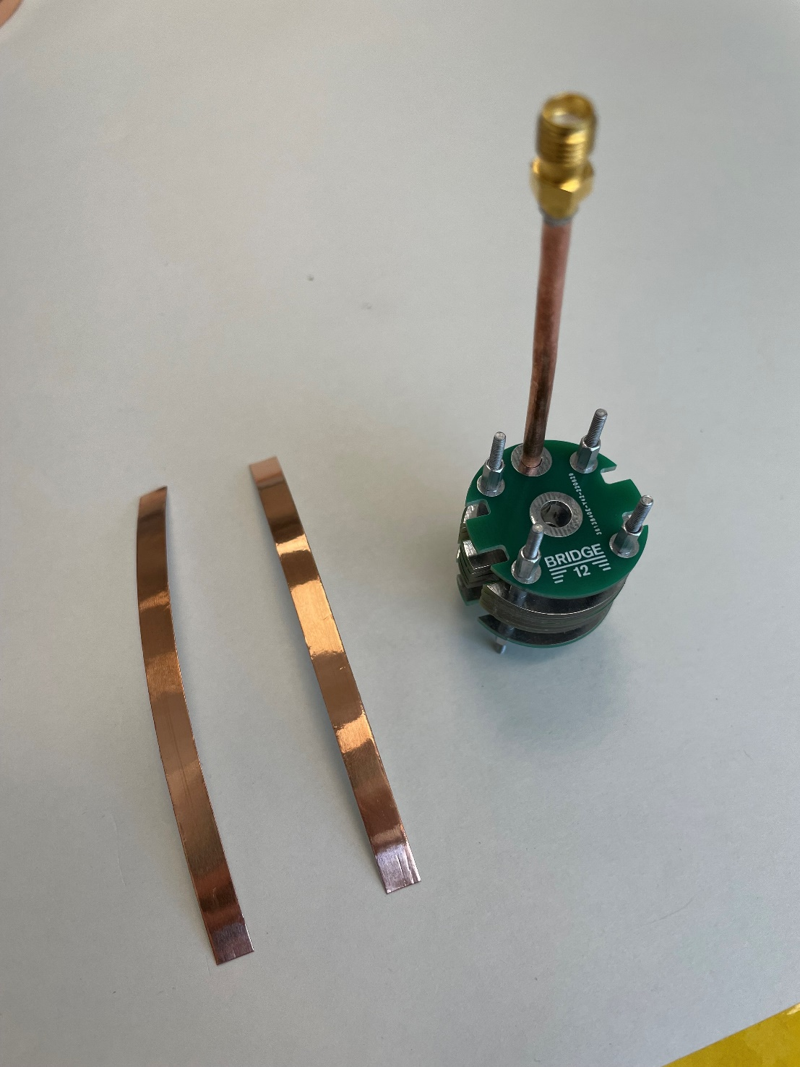

1. From one of the 0.250 in spacers closest to the coupling loop, start wrapping 0.250 in copper tape around the PCB LGR.

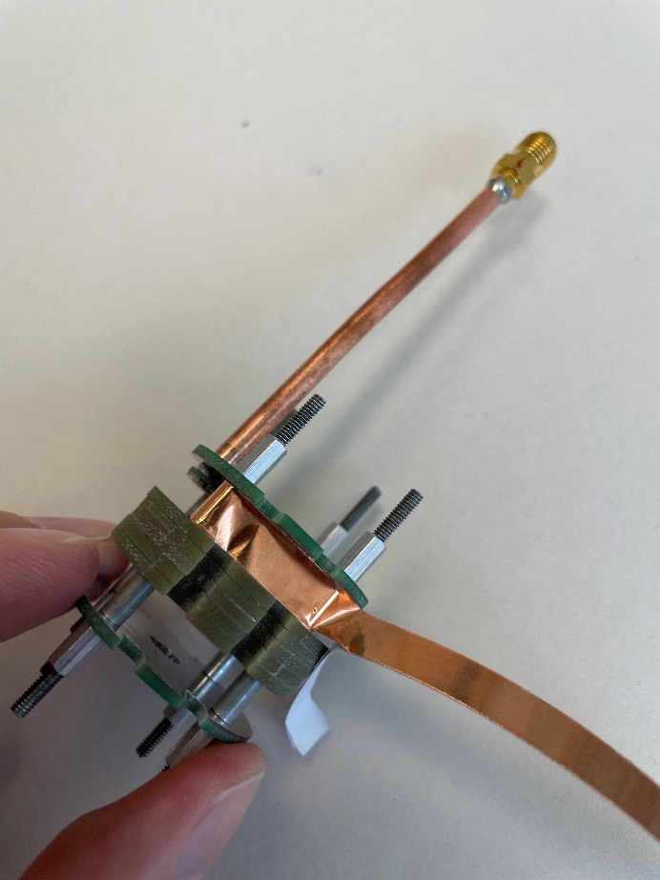

1. Wrap the tape all the way around the PCB LGR and leave a section open for the coupling loop.

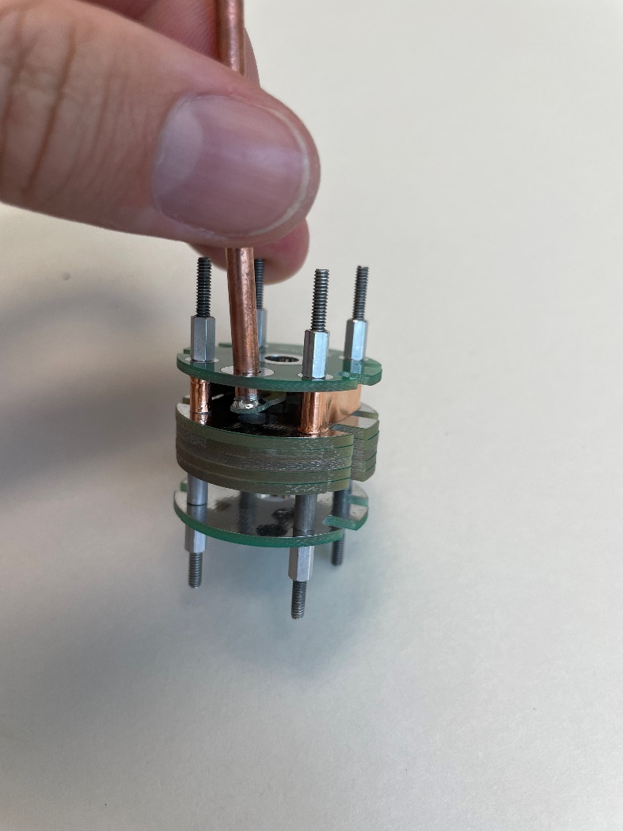

1. Repeat the same process for the bottom gap, but this time completely wrap the 0.250 in copper tape around the resonator.

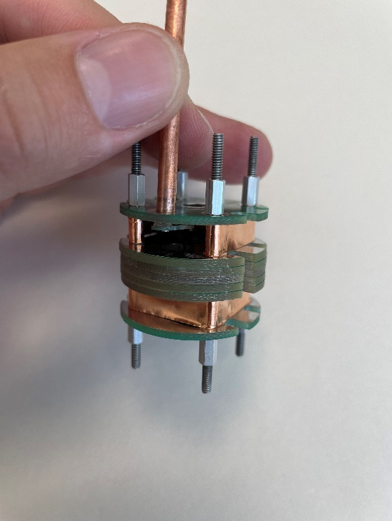

## Winding Modulation Coils

1. Start winding 30 AWG magnet wire around the resonator. The wire should go through the slots on the side of the resonator. The wire can be wrapped around the standoffs to prevent the wire from unraveling during the first turn.

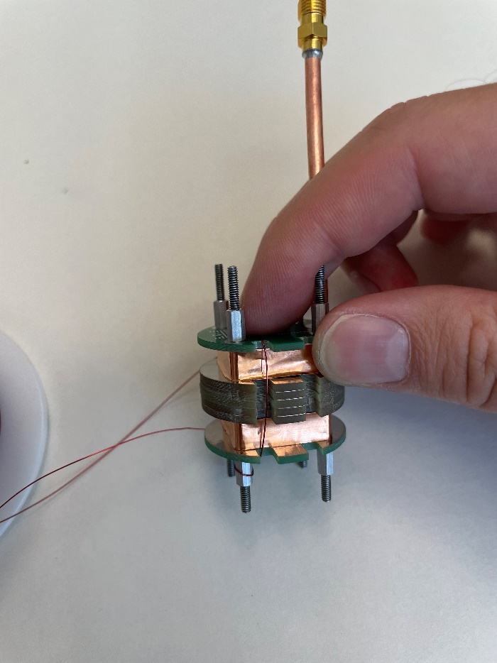

1. Continue wrapping wire around the resonator.

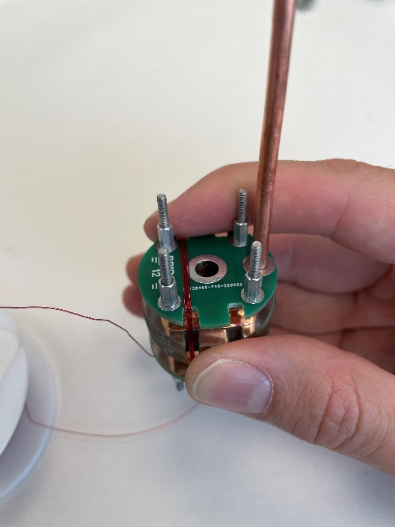

1. Complete 50 turns around the resonator.

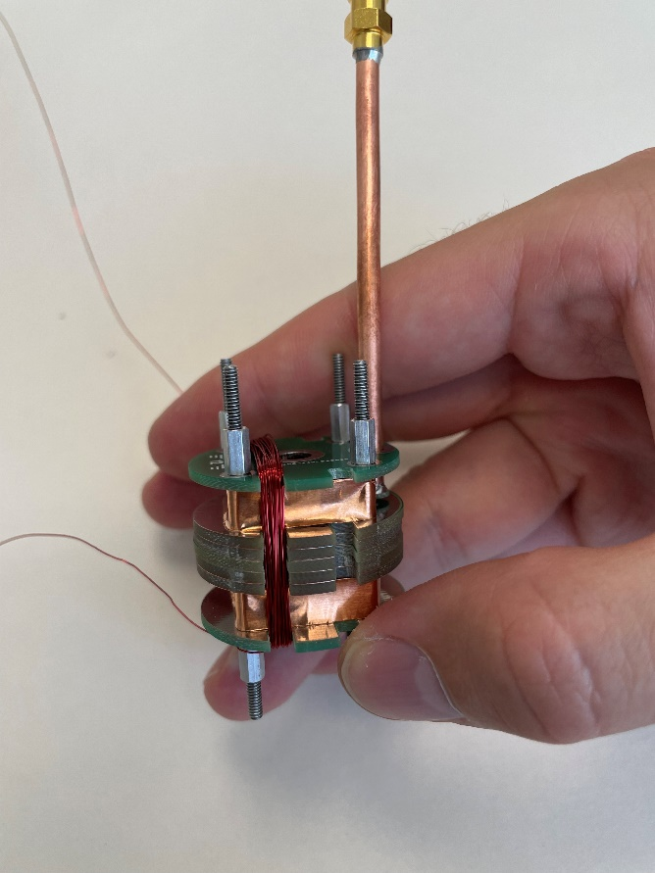

1. Cross the wire over to the slots on the other side of the resonator and continue winding the same direction around the resonator.

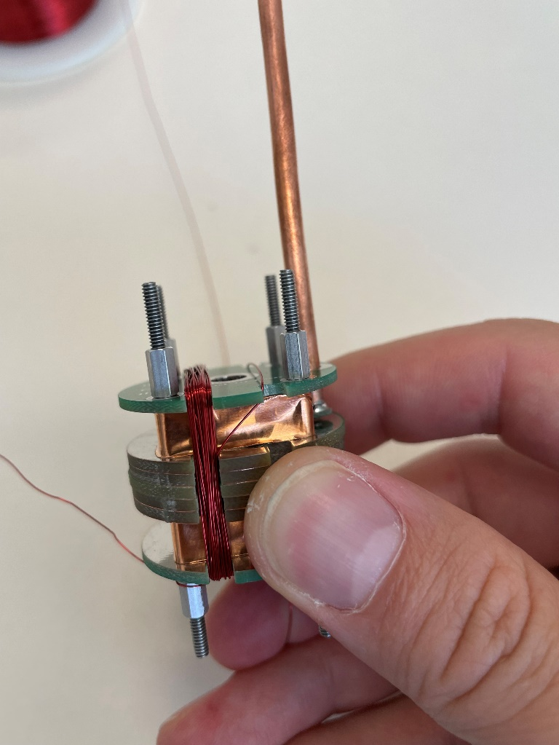

1. Complete 50 turns of wire on the other side of the slots.

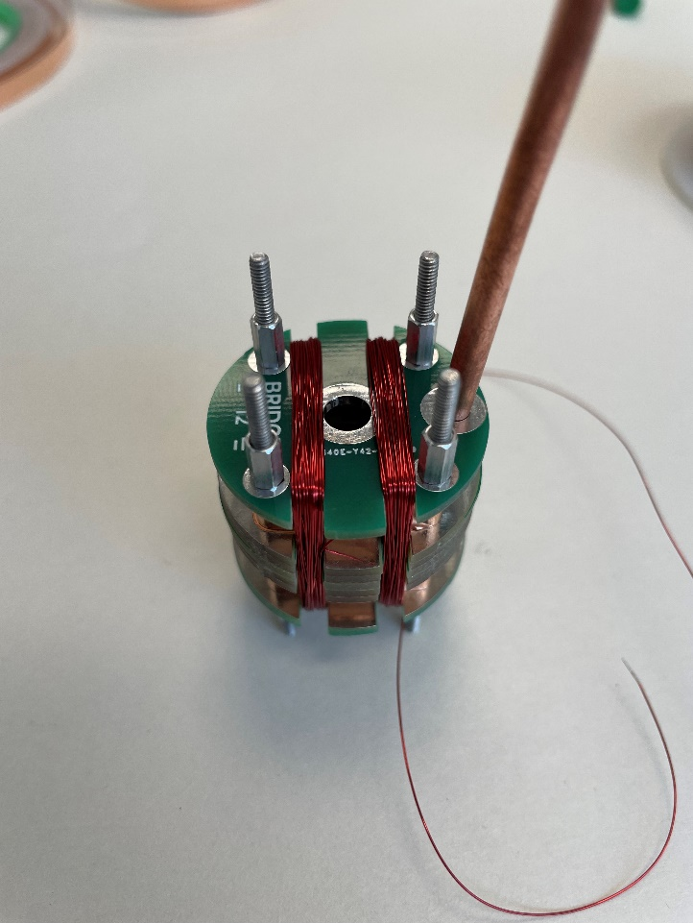

1. When completed, the resistance of the modulation coil should be 2-4 ohms.

## Applying Copper Tape to Shield

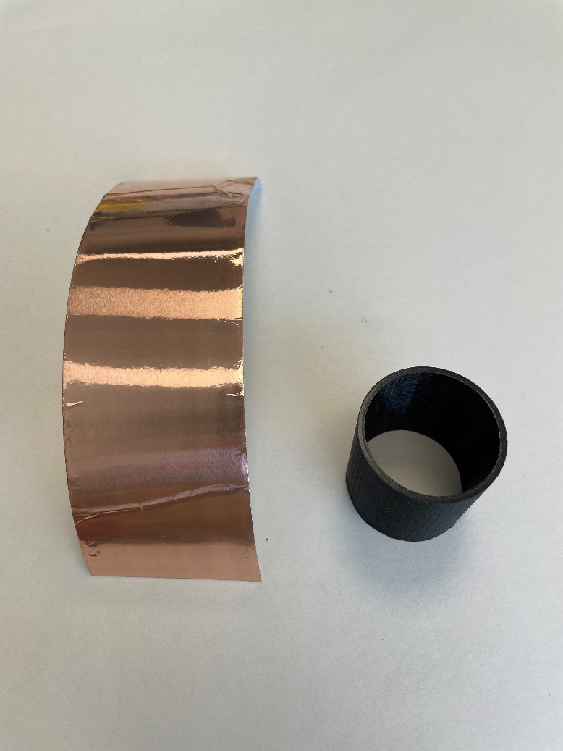

1. Cut 2.000 in width copper tape to approximately 1.5 in length pieces.

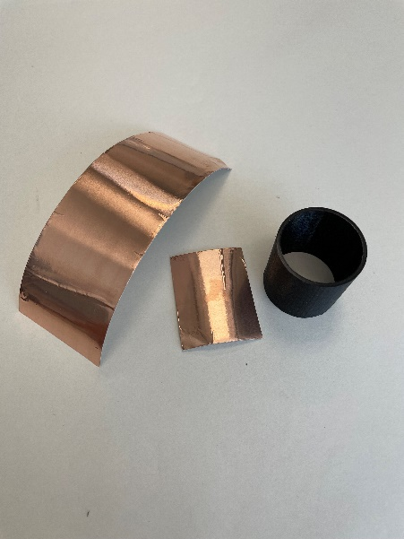

1. Apply copper tape to inside of shield.

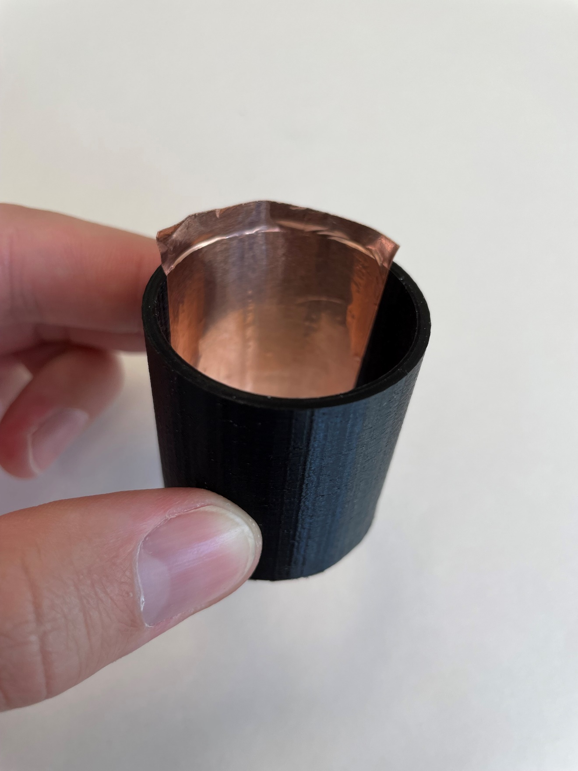

1. Repeat applying approximately 1.5 in length sections of the copper tape until the entire inside is covered with copper tape.

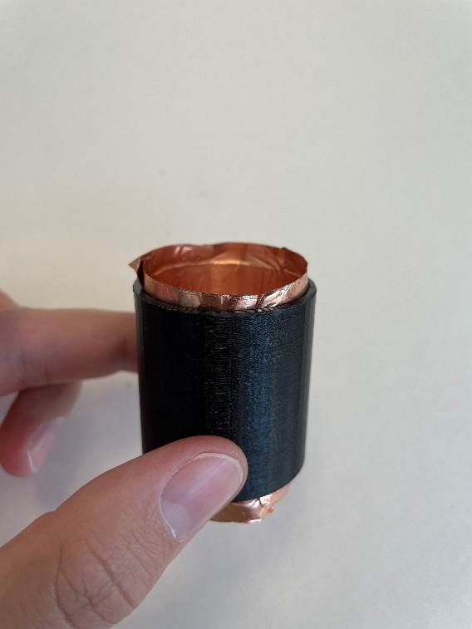

1. With a scalpel, remove excess copper tape from the ends of the tube.

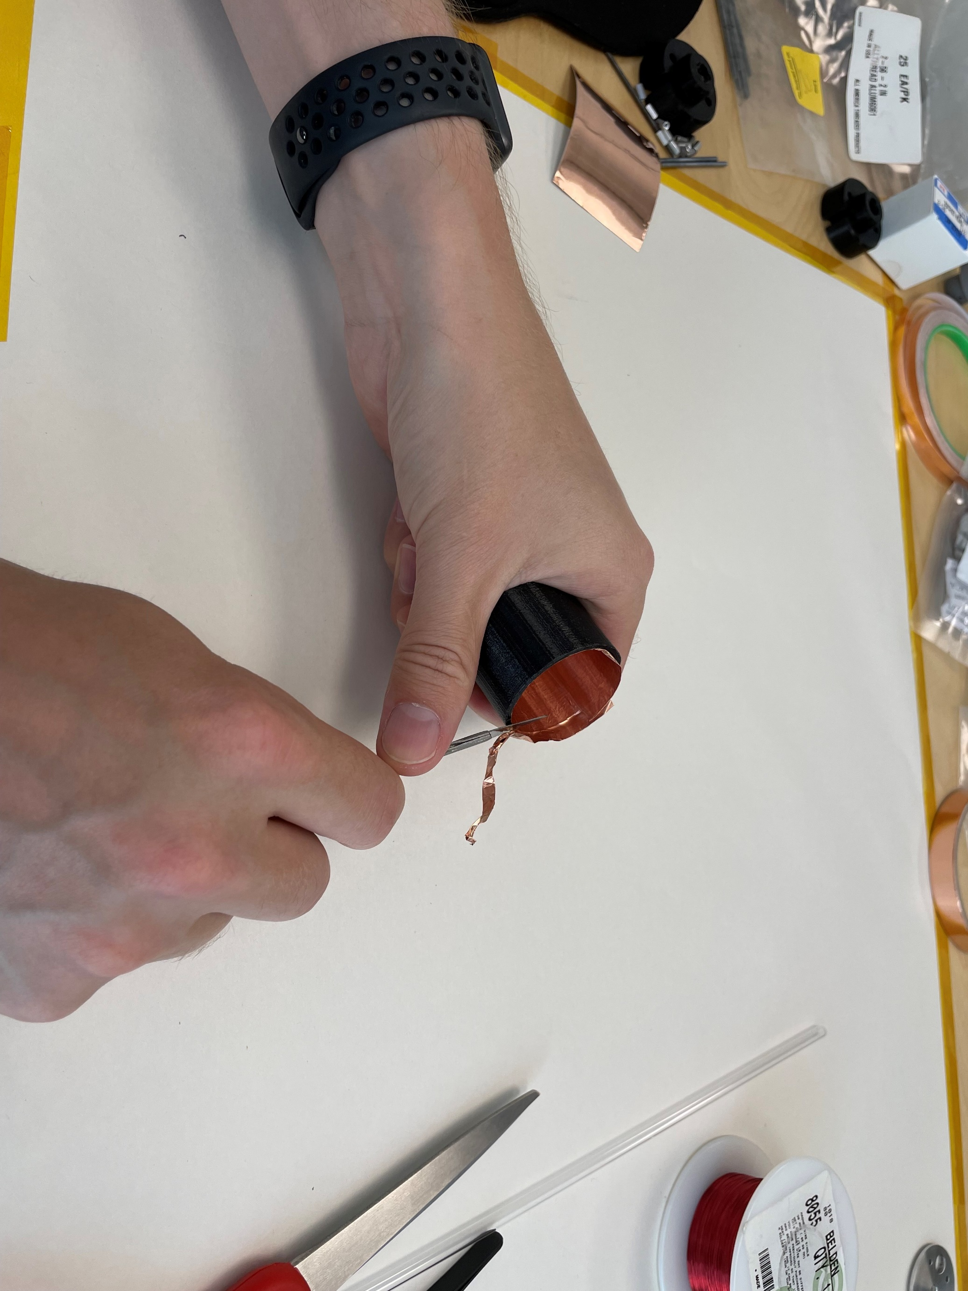

1. The completed shield should appear as shown:

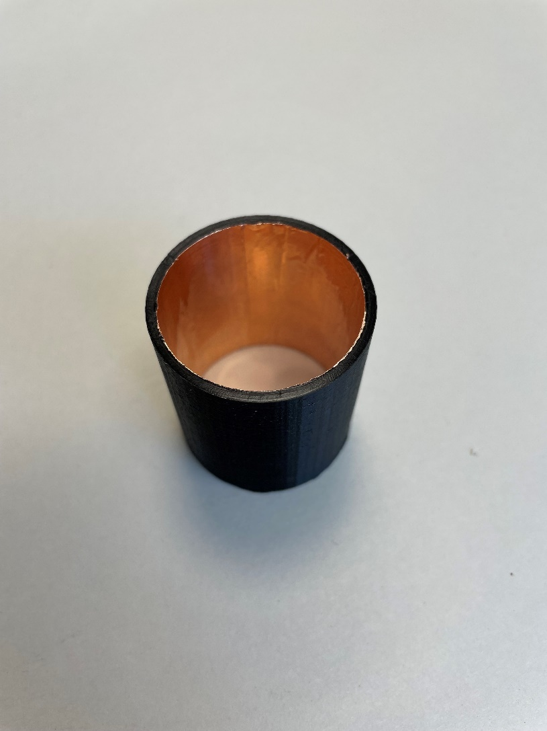

## Assembling the Shield

1. For all 3d printed parts, ensure a proper clearance for all #2 screws. 3D printed parts often have undersized holes. If necessary, drill holes with a #41 drill (0.096 in).
2. Slide bottom of shield through 2-56 threaded rods.

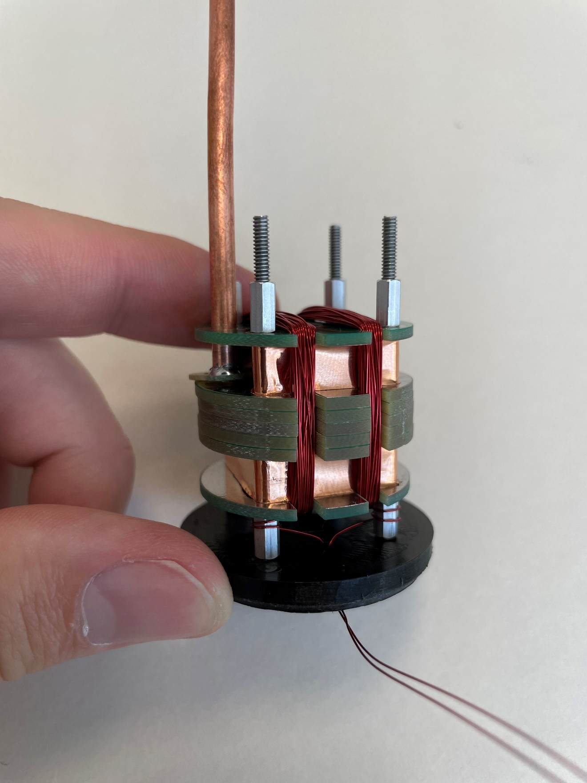

1. Screw 0.250 in standoffs onto 2-56 threaded rod to secure the bottom in place.

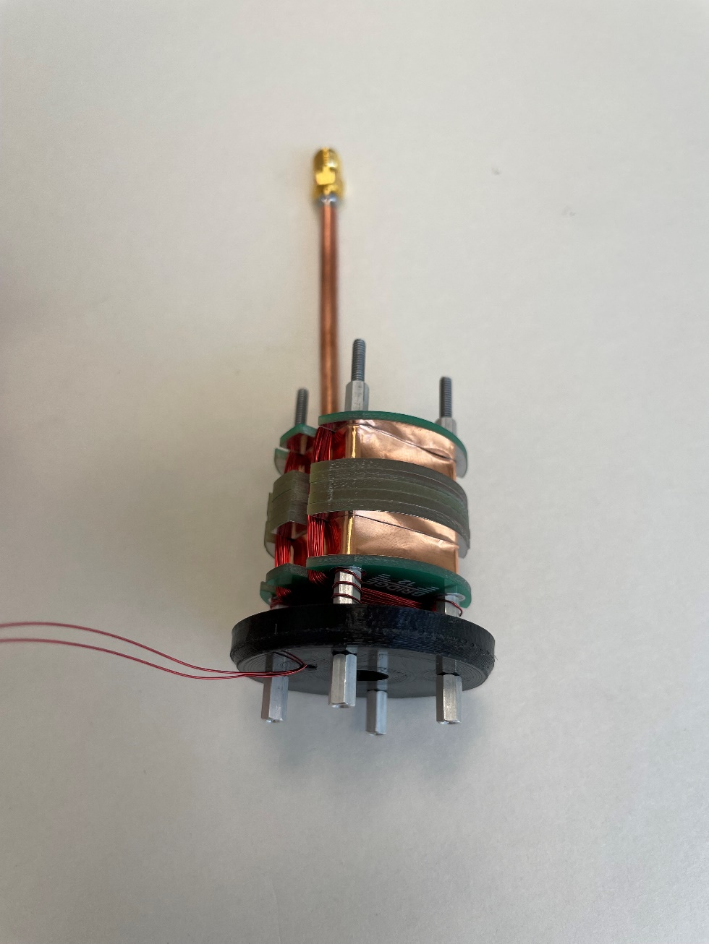

1. Slide the shield over the PCB LGR.

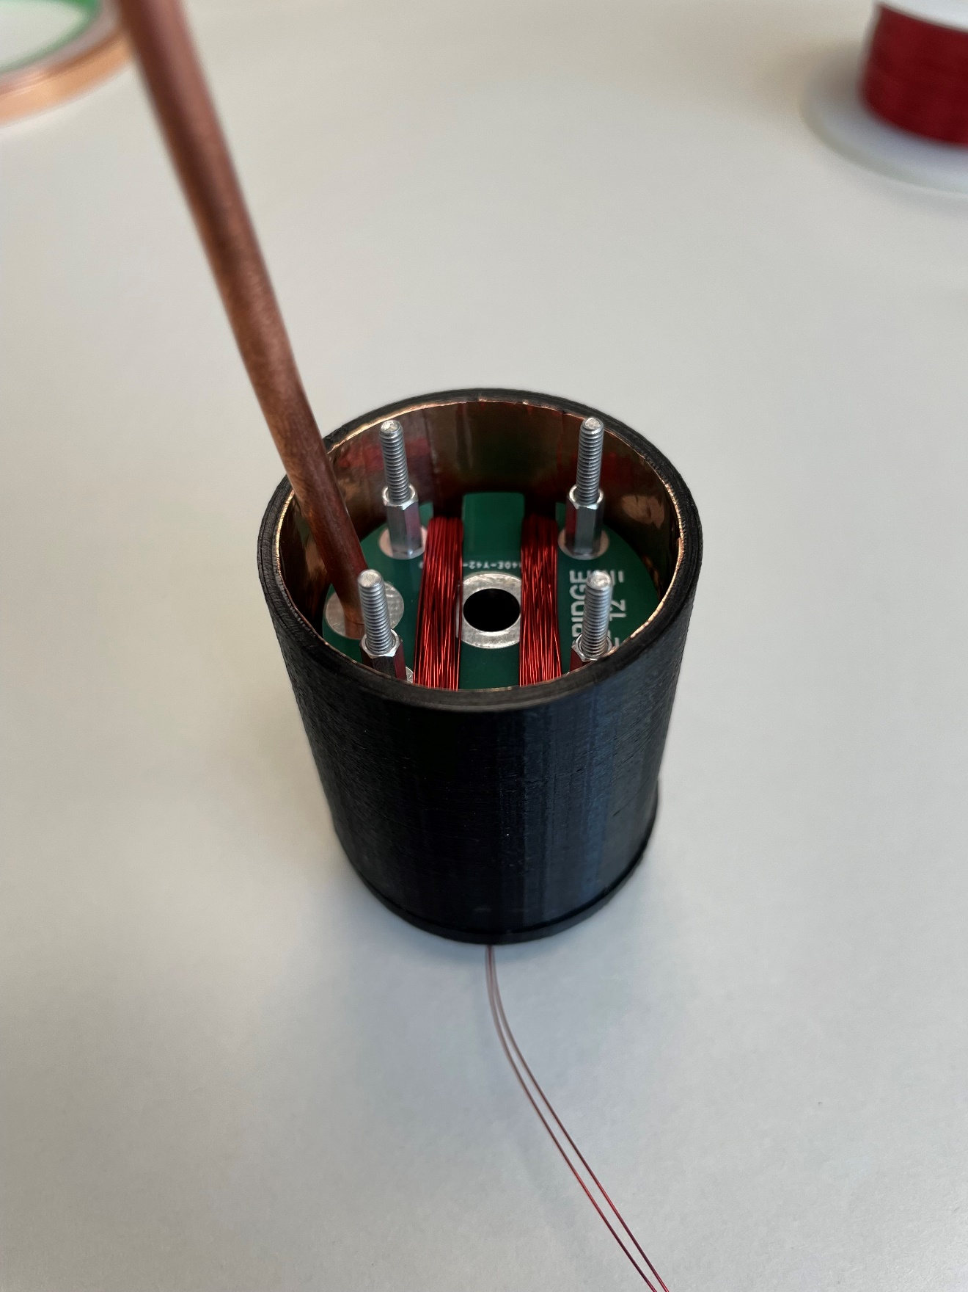

1. The shield top should slide into place over the shield.

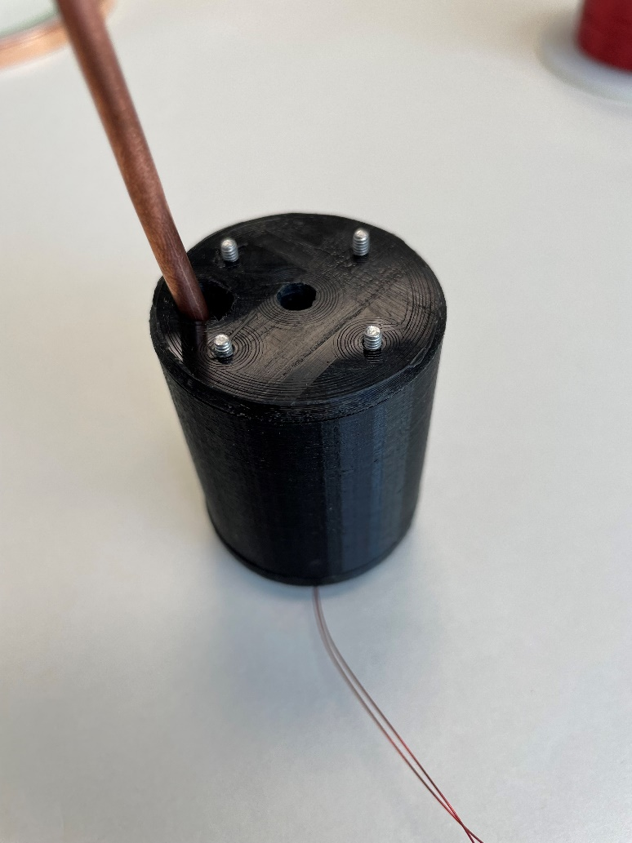

1. The coupling loop support now snaps into place around the semi-rigid coax. It can be quite tight, but this will help to hold the coupling loop in place.

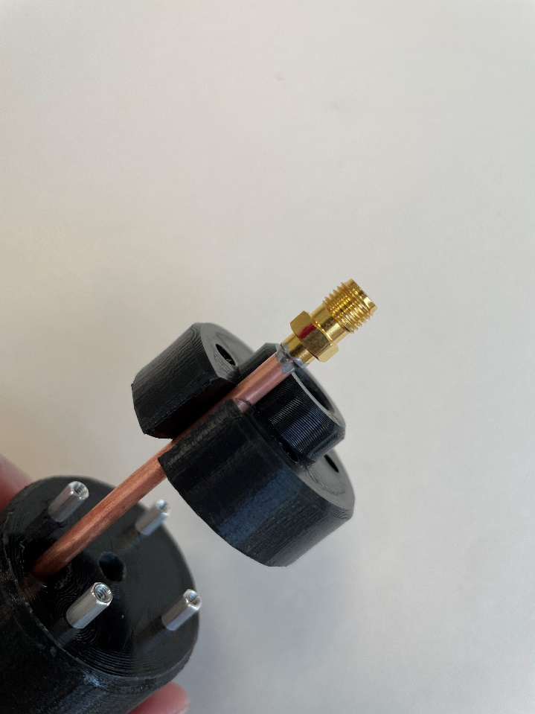

1. Slide the coupling loop support into place above the 0.250 in standoffs.

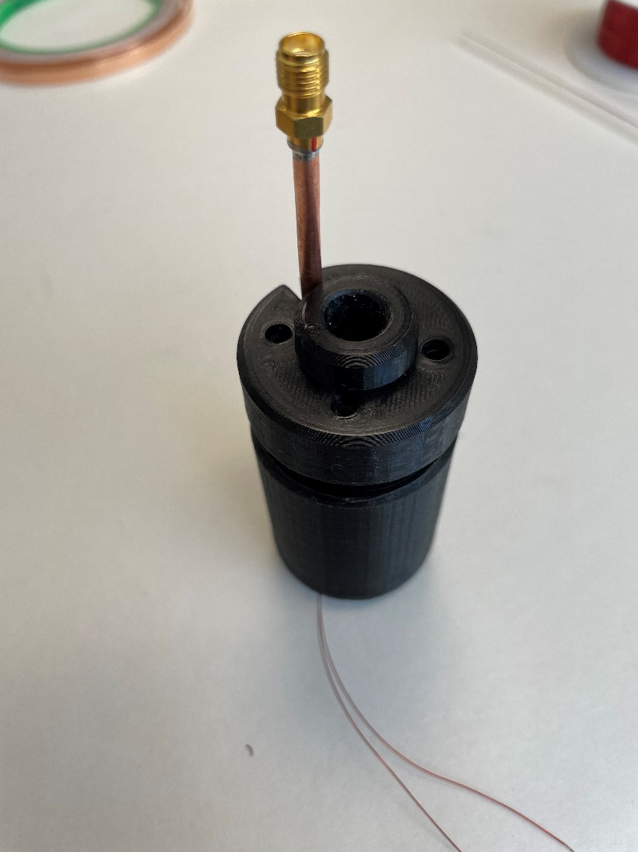

1. Screw the 0.500 in length 2-56 socket head screws into the coupling loop support.

# Bill of Materials

|  |  |  |  |  |  |
| --- | --- | --- | --- | --- | --- |
| **ITEM NO.** | **PART NO.** | **DESCRIPTION** | **VENDOR** | | **QUANTITY** |
| 1 | 121003116 | PCB LGR | B12T | | 5 |
| 2 | 121003117 | PCB LGR TOP | B12T | | 1 |
| 3 | 121003118 | PCB LGR BOTTOM | B12T | | 1 |
| 4 | 92511A129 | SPACER #2 0.250 LG | MCMASTER | | 8 |
| 5 | 91780A023 | STANDOFF 2-56 0.250 LG | MCMASTER | | 16 |
| 6 | 93225A413 | THREADED ROD #2 2.000 LG | MCMASTER | | 4 |
| 7 | ACX2083-ND | CONN SMA JACK STR 50 OHM SOLDER | DIGIKEY | | 1 |
| 8 | FMBC007 | UT-141C COAX 3.000 LG | FAIRVIEW | | 1 |
| 9 | 121003119 | PCB COUPLING LOOP 4MM-6MM | B12T | | 1 |
| 10 | 76555A721 | COPPER TAPE 0.250 WD 4.000 LG | MCMASTER | | 1 |
| 11 | 76555A725 | COPPER TAPE 2.000 WD 6.000 LG | MCMASTER | | 1 |
| 12 | 92185A083 | SCREW 2-56 SOCKET HEAD 0.500 LG | MCMASTER | | 4 |
| 13 | 121003107 | PCB LGR SHIELD | B12T | | 1 |
| 14 | 121003108 | PCB LGR SHIELD TOP | B12T | | 1 |
| 15 | 121003143 | PCB LGR SHIELD BOTTOM | B12T | | 1 |
| 16 | 121003110 | PCB LGR TOP SUPPORT | B12T | | 1 |
| 17 | 2328-30SNSP.125-ND | 30 AWG MAGNET WIRE | DIGIKEY | 1 | |

# Sample EPR Spectra

# References